Unlocking Thesis Data

University of East London case study

Michael Whitton
http://orcid.org/0000-0001-6838-1100

Sara Gould
http://orcid.org/0000-0003-2763-9755

June 2015

DOI: 10.15123/PUB.4301

© The authors 2015. Licenced under Creative Commons Attribution 3.0 Unported License.
Overview of UEL

Summary Table
Institution | University of East London
Higher Degrees Awarded in 2012/13 | 55 ()
Thesis submission | Electronic
Publications repository | EPrints (ROAR)
Publication repository IDs | Handles
Data repository | EPrints (data.uel)
Data repository IDs | DataCite DOIs
Theses held in… | Hard-copy and Electronic

In the beginning …
Most students enrol on a PhD by MPhil.
A student registers (within 6 months of enrolment), and completes a form including a provisional thesis title, and how the research will be conducted.
At about 12 months, students can initiate a transfer process (from MPhil to PhD) including a form, 3-6 thousand word report and an internal meeting between the student and their school. If appropriate the school would recommend transfer to the University Research Degrees Subcommittee, which gives formal approval to proceed.
When ready to submit, the student submits an ‘Exam arrangements’ form – this includes Thesis title, and the proposed supervisors (and their CVs). This is approved at School and University level (to ensure examiners are suitable, and the form is completed correctly), and the Graduate School is informed. Students then have up to 6 months to submit a thesis. This information is stored on a database by the Graduate School, which also includes the student number.

The PhD examinations process
The Graduate school manages all examination and viva processes. The student submits soft-bound copies to the Graduate School, for examination. These are then sent to the examinations team, who typically have 4-6 weeks to assess the thesis. The thesis can be supplied in digital form if an examiner would prefer this, e.g. if they are abroad.
There are checks to ensure the thesis title is correct – this can be changed with an appropriate form (approved by their supervisor), or a minor change from the examination process.
The examiners can go ahead with the viva, or choose to delay this. The chair then records the outcome of the examination: typically (80-90%) either minor or major changes are needed. It is also possible to be approved without changes, not approved or only awarding an MPhil.
The student is then informed of the result by the Graduate School. If changes are needed the student may submit the new version electronically, with a letter summarising what has been changed. Files are sent to the Graduate School in PDF/A format by email (or UEL file transfer system for larger files).
- Checks are made against a retained softbound copy that this is the correct version, with the same number of pages etc.
- The process will stop if the final version is not received.
- Files are stored by the Graduate School on a networked drive
- The student decides what files or additional supplementary files are submitted for examination.
The Deposit Agreement (EThOS form) is either received in print, or a scanned signed copy is emailed to the Graduate School. This is kept in the student’s file.
Typically one examiner looks at the new version (they get 3 weeks), and usually will approve or request further changes. Correction of typos etc. can be requested and completed by the Graduate School; more significant changes would go back to one or more the examiners for approval.
The paperwork is sent to the Head of the Graduate School and the Vice Chancellor for final approval and sign-off.
After final approval the student is informed, and certificate and a graduation ceremony are arranged.
The Graduate School deposits in the repository
Graduate School staff deposit the thesis onto ROAR (UEL publications repository, http://roar.uel.ac.uk), with supplementary files added to the same record. These are added in batches, copying information (name, thesis title, school) from the ‘PhD examination arrangements’ database, and the abstract directly from the PDF.
Graduate School staff are encouraged to contact the Repository Manager about issues relating to supplementary files – in practice such enquires are rare. Most theses are a single PDF file. The student chooses what is presented for examinations – there are examples of theses with supplementary files including videos () and statistical data ().
All theses are made available under a Creative Commons Attribution Non-Commercial No Derivatives (CC-BY-NC-ND) licence. Embargos of up to 2 years are permitted (but rarely requested in practice) – they need to apply in advance and get their supervisor’s approval.
The Library approves the deposit in the repository
The Repository Manager reviews the records in ROAR before making them them live (“publishing”).
- There are some basic checks of the thesis PDF – e.g. for ‘tracked changes’ left in or confidential material that is not appropriate to make publically available. The latter is especially an issue for Psychology professional doctorate theses.
- Some of these issues can be fixed directly, others require contacting the student.
- Basic checks of the metadata in the thesis record – e.g. the department and abstract are included.
- A new post, Assistant Librarian (Open Access) was recently recruited to help with publishing Theses (and other publications) on ROAR.
Students are not normally informed when their thesis goes live on ROAR, although some are notified if the Graduate School has been in contact during the process
Print theses used to be catalogued, but Primo indexes ROAR so this is no longer needed. The Library may remove existing catalogue records in the future, though no decision has been made. Many retrospectively digitised theses are only available to UEL students and staff, since they do not have permission to make them open access.
Reflections on the process
UEL expects more staff publications to be deposited due to the HEFCE/REF mandate. Almost all deposit is via a mediated service offered by the Library.
Supervisor and funding information is not added to the record in ROAR, though both elements are often in the thesis acknowledgements, and the supervisor is recorded on various forms. Very few PhDs at UEL receive external public funding, and this information is not recorded in the Graduate School’s paperwork or database.
It would be good to obtain a personal email for more students to be held in the ‘examination arrangements’ database. The Graduate School is not always in touch with students during the exam period and may lose touch soon after they leave UEL. A personal email is useful to be able to contact students after award, for example when uploading to ROAR, e.g. for 3rd party copyright issues.
Guidance
The Repository Manager has had a limited amount of contact with students about technical issues, or depositing data/supplementary files. Academic schools do not contact the library about theses.
Documentation is on the Graduate School website – there are plans to improve this because the guidance is split across several documents. Also the Graduate School offers sessions on the thesis examinations process. There is guidance for the title page (often includes the School), but no specific guidance for the abstract – but the Graduate School do check it is present.
The guidance encourages students to contact the Repository Manager for guidance about non-PDF format files. This may need to be reconsidered in the future, especially if many more datasets are deposited.
The Future - DOIs
There is a CoinDOI button in ROAR for the Repository Manager to add a DOI, and no additional permissions within the University would be required to start creating thesis DOIs.
- A thesis DOI would use the student number (which are of the form 123456/1, the final digit indicating the level of study) and require this to be on the title page.
- E.g. 10.15123/THESIS.123456 (UEL prefix/Thesis item.Student no.)
- This would be assigned at registration, but only activated on publication of the thesis in ROAR.
This DOI could be promoted when the Graduate School send students they have been in contact with a link to their thesis on ROAR.
The Future - ORCIDs
ORCiD implementation has not yet been adopted in UEL, but planning has started. There is a preference for a system that would register PhD students with ORCID when they register for their degree.
- The registration forms could be sent to the Repository Manager, who would apply for an account on the student’s behalf.
- The student would receive an email from ORCID, and need to approve the creation of the account.
- This would allow for students to use the ORCID if they publish.
- This process is in the initial stages of being implemented at UEL.
ORCID implementation for academic staff would be led by the Library and ReDS (Research and Development Support). If students are also included, this would enable tracking of the future academic activity of students who use their ORCID.
ORCIDs are an optional field in the HESA return – responsibility for completing the HESA return for research students is moving from the Registry to the Graduate School. Due to the changes, it is unclear how easily ORCIDs could be included in the return.

Appendix: Suggested workflow with PID creation
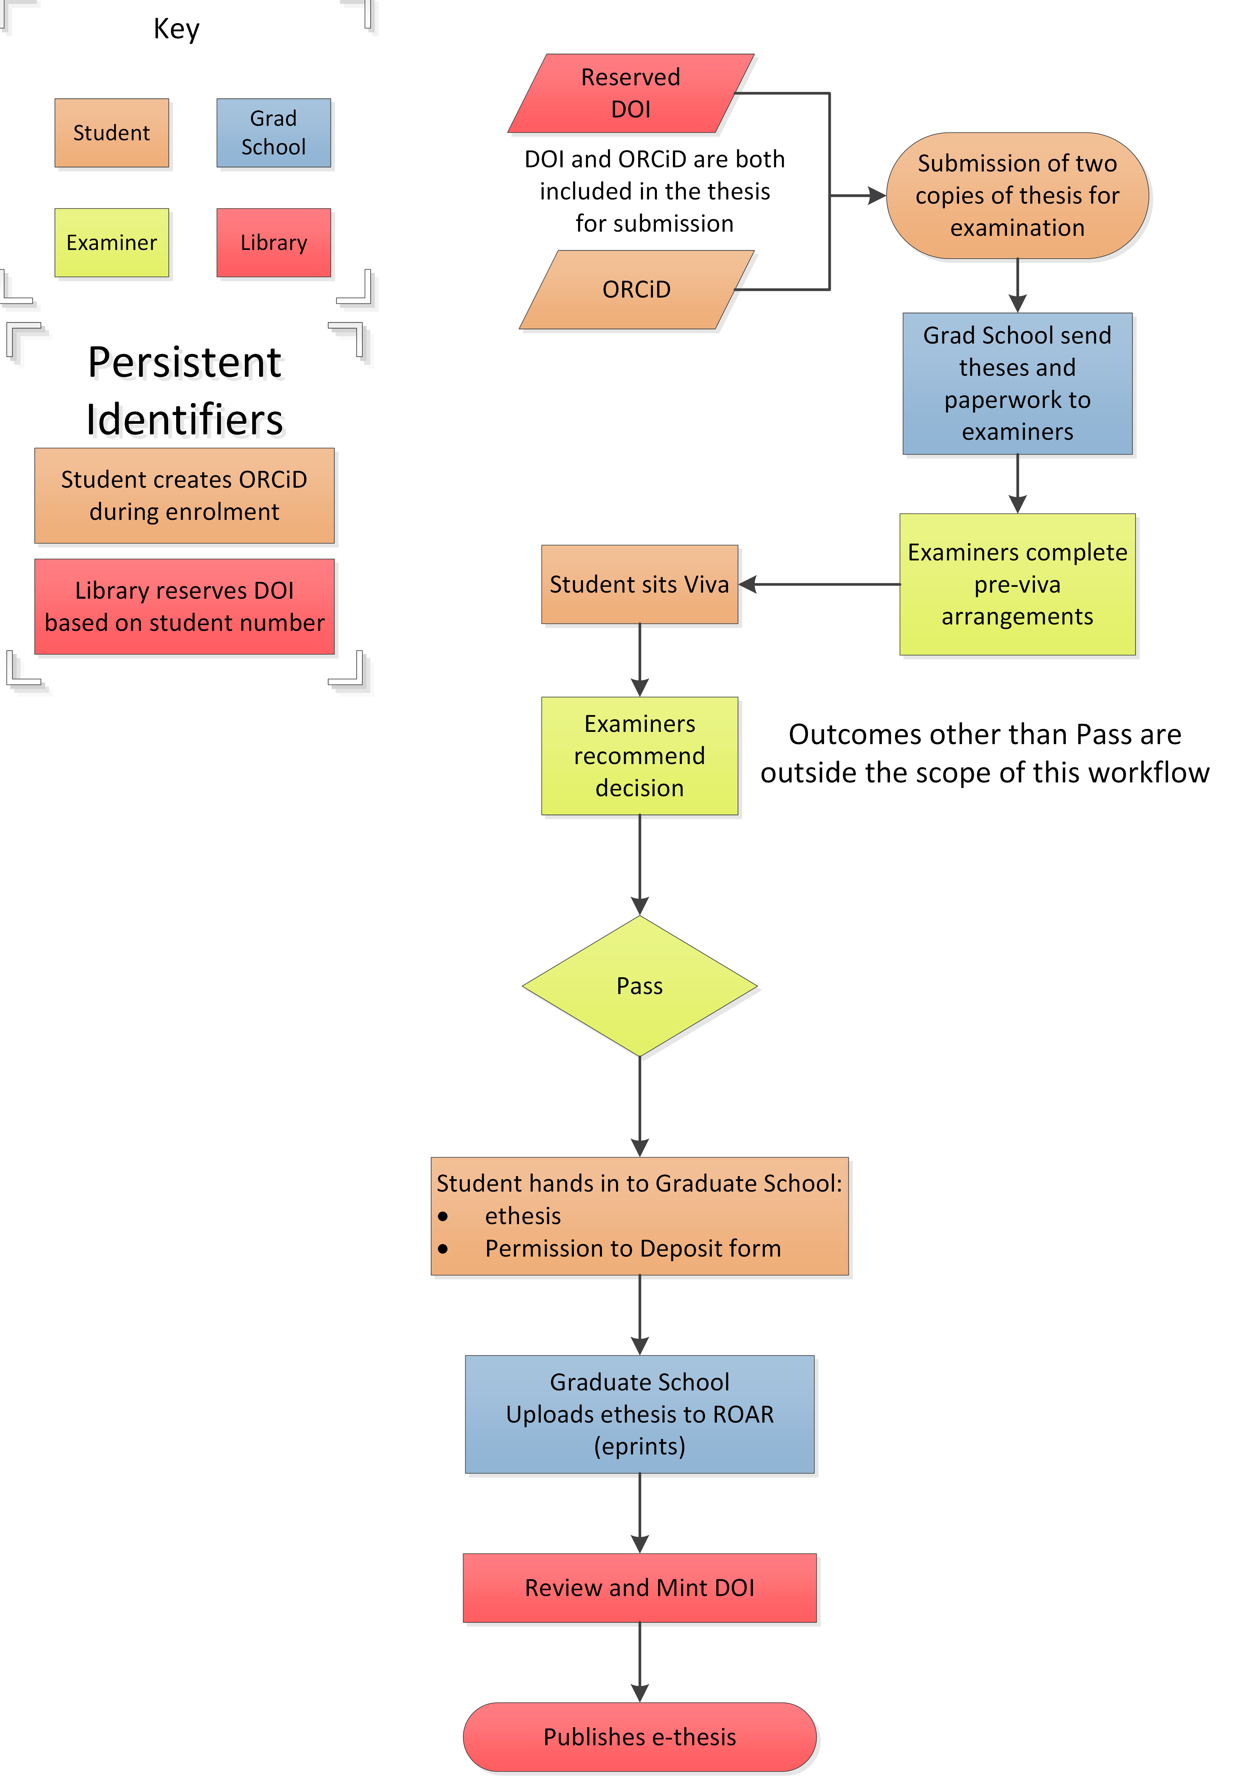

From HESA Table 18a, Higher Degree (Research) Qualifiers by Institution and Subject of Study
Daniels, Jill (2014). Memory, Place and Subjectivity: Experiments in Independent Documentary Filmmaking. PhD thesis, University of East London. http://hdl.handle.net/10552/3929
Fontaine, Laura (2013) Racial Identity Attitudes, Africentrism, Self-Esteem and Psychological Wellbeing in Black Men: A Mixed Methods Study. Professional doctorate thesis, University of East London. http://hdl.handle.net/10552/3045

